**AGENDA: LIBRARY BOARD MEETING**

Tuesday, February 11, 2025 at 6 p.m.

At the Sioux Rapids Memorial Library

**CALL MEETING TO ORDER**

# APPROVE AGENDA

1. Approve minutes from previous meeting
2. Approve monthly bills/financial report

# DISCUSSION AND ACTION ITEMS

1. Board CE classes reported
2. Prohibition Program discussion/decision – where to have the program
3. Erate for new year, status of last form?
4. Discussion & Decision about Closing policy
5. Discussion & Decision about Janitorial policy in handbook
6. Budget/moving update from council meeting
7. Director reporting

# ADJOURNMENT

Next meeting to be March 11, 2025 @ 6:00 p.m.

2-11-25 Minutes for Sioux Rapids Public Library

PRESENT: Denise, Jamie, Dorothy, and Suzie

Called to order at 6:03 pm

1. Approved minutes—Dorothy approved, Jamie seconded
2. Approve monthly bills/financial report—approved
3. Board CE classes—none
4. Prohibition Program—possibly could do in new Library—Theatre is the first choice—Dorothy talked to Ginny.
5. E-rate for the new year—471 form still needs to be done
6. Discussion & Decision about closing policy—School closed, Library Closed—Leave it up to Librarian to decide whether to be open or not. Motion—Denise—Seconded by Jamie
7. Discussion regarding Janitorial policy—vote to eliminate that section of the handbook. Common sense as to when it should be cleaned.
8. Budget/moving update for the council meeting—budget accepted by council. Moving-- possibly not moving for 18 months due to FEMA regulations.
9. Director reporting—Wed. 2-12-25 Coffee with the Director 9-10am

Daycare Storytime Friday morning

Wednesday 1:30pm Story time with TK at the school.

Program ideas:

Daddy/Daughter Dance—ask Jim or Aaron if Fire Station can be used.

Adult Prom—could do a theme

Bingo—adult—maybe have baskets donated for prizes

Ag

Sioux Rapids Memorial Library FEBRUARY 2025 Claims Report

# Bills Paid After Meeting JANUARY Meeting

|  |  |
| --- | --- |
| Alliant Energy-01-06-25 | $361.05 |



Total $361.05

# Bills Needing Approved for Payment

|  |  |
| --- | --- |
| Evertek, Inc. 02-01-2025 | $57.48 |
| GCF Leasing 03/05-04/03/25 | $105.31 |
| Baker & Taylor | $34.97 |
| Baker & Taylor | $150.55 |
| HRS Hanigan Writing Services | $50.00 |
| Postage - Petty Cash January | $0.73 |



Total $399.04

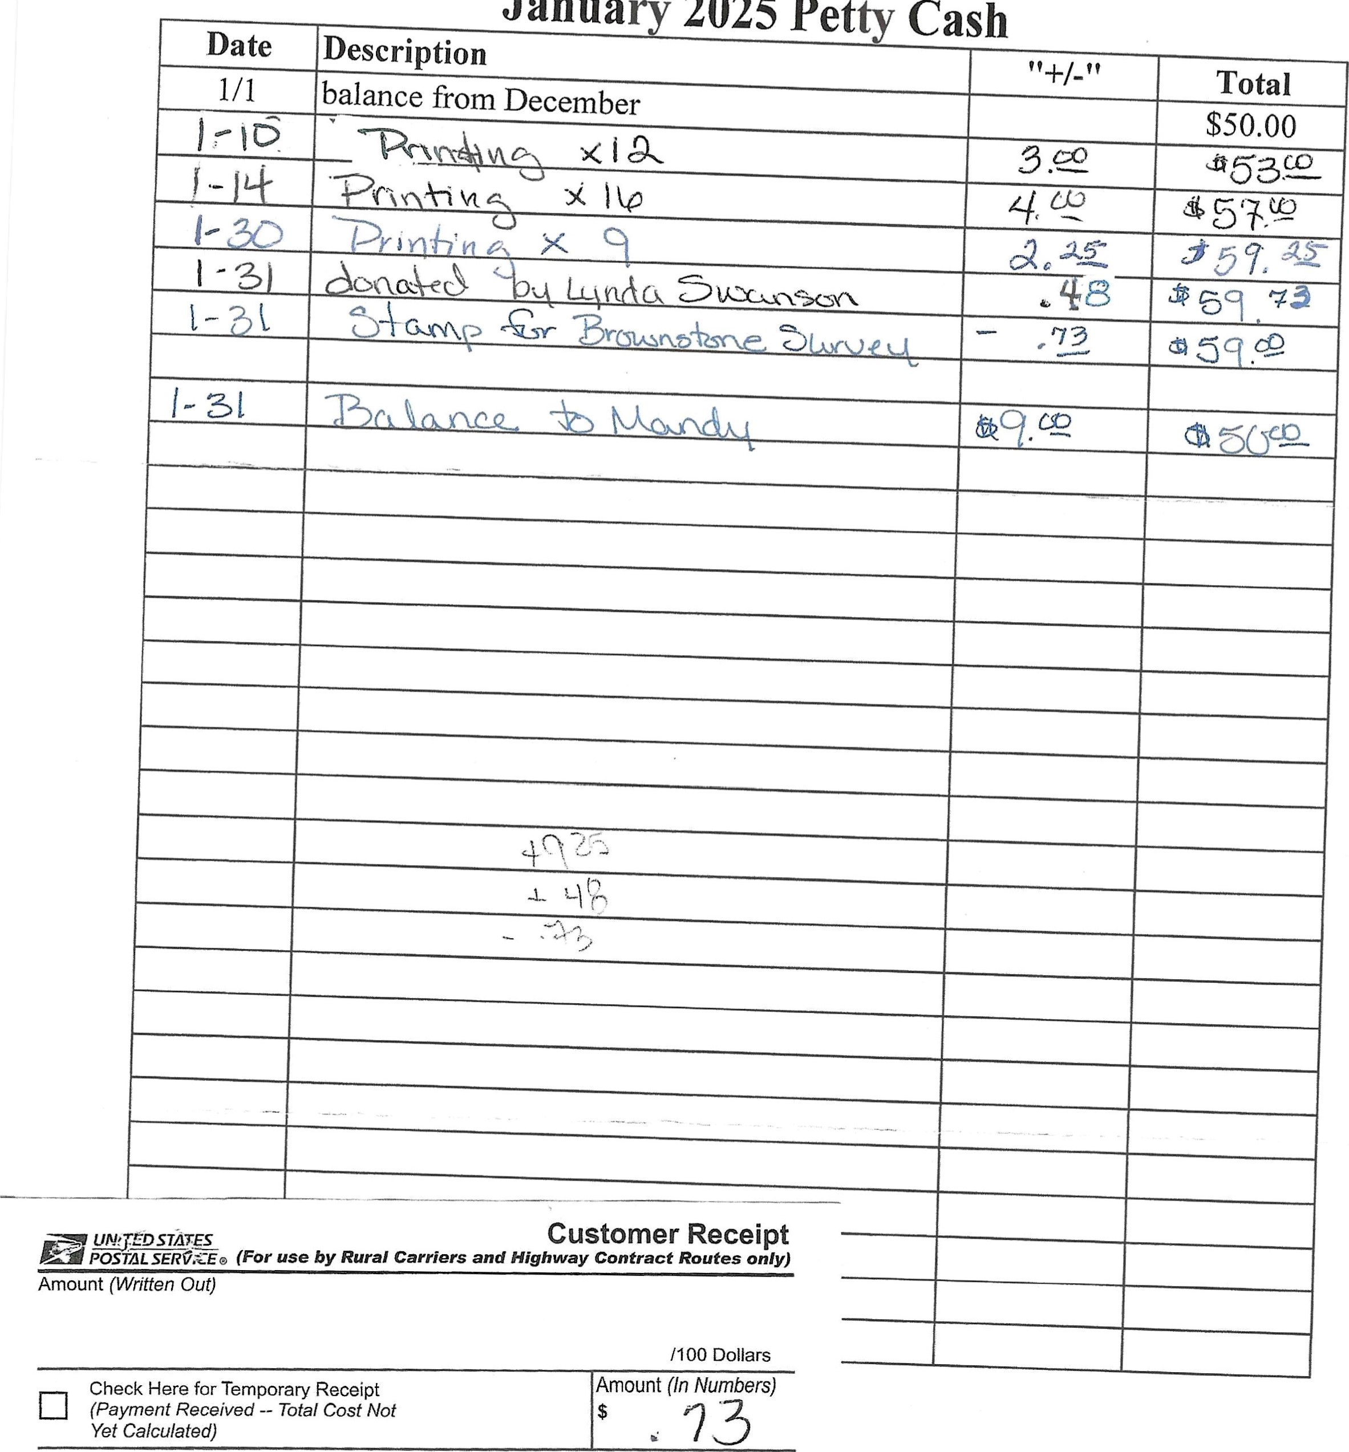

Janua

2025

Pet

Purpose

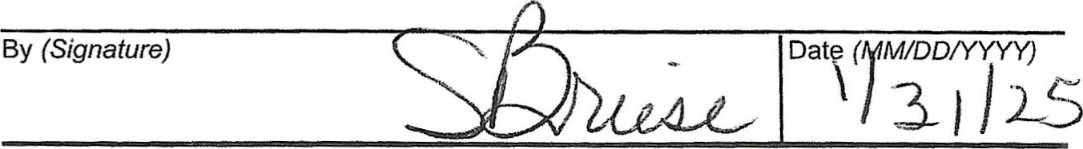

ps Form 1096, October 2009 PSN 7530-02-000-7346

Community

www.ecommunitybank.org

|  |  |  |  |
| --- | --- | --- | --- |
| PHONE 712-843-2211 | 208 MAIN ST. | ALBERT CITY IA 50510 |  |
| PHONE 712-852-2201 | 2407 MAIN ST. | EMMETSBURG, IA 50536 |  |
| PHONE 712-845-2627 | 102 S. 3RD ST. | LAURENS, IA 50554 |  |
| PHONE 712-425-3436 | 602 INMAN ST. | MALLARD, IA 50562 |  |
| PHONE 712-283-2593 | 123 MAIN ST. | SIOUX RAPIDS, IA 50585 |  |
| PHONE 712-262-3030 | 1812 HWY BLVD. | SPENCER, IA 51301 |  |
| PHONE 712-838-4321 | 115 MAIN ST. | WEBB, IA 51366 | MEMBER FDIC |

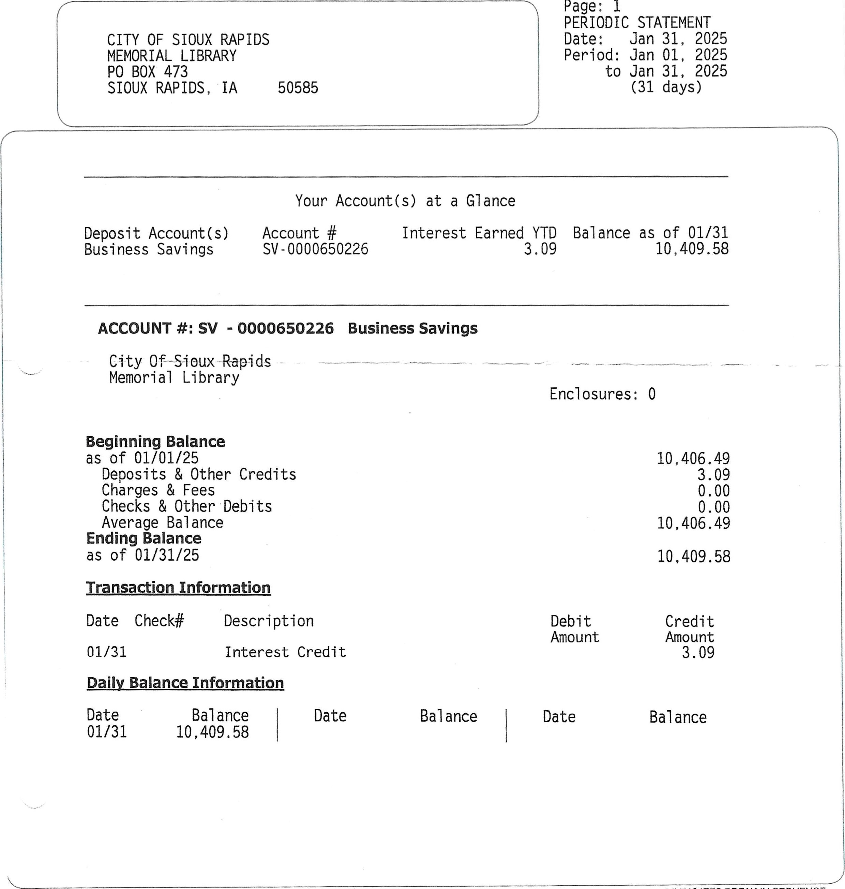

In case of error or questions about your electronic transfers - see reverse side. * INDICATES BREAK IN SEQUENCE

# BUDGET REPORT

CALENDAR 1/2025, FISCAL

|  |  |  |  |  |  |
| --- | --- | --- | --- | --- | --- |
|  | TOTAL | MTD | YTD | PERCENT |  |
| ACCOUNT | BUDGET | BALANCE | BALANCE | EXPENDED | UNEXPENDED |

|  |  |  |  |  |  |  |  |  |  |  |  |  |  |  |  |  |  |  |  |  |  |  |  |  |  |  |  |  |  |  |  |  |  |  |  |  |  |  |  |  |  |  |  |  |  |  |  |  |  |  |  |  |  |  |  |  |  |  |  |  |  |  |  |  |  |  |  |  |  |  |  |  |  |  |  |  |  |  |  |  |  |  |  |  |  |  |  |  |  |  |  |  |  |  |  |  |  |  |  |  |  |  |  |  |  |  |  |  |  |  |  |  |  |
| --- | --- | --- | --- | --- | --- | --- | --- | --- | --- | --- | --- | --- | --- | --- | --- | --- | --- | --- | --- | --- | --- | --- | --- | --- | --- | --- | --- | --- | --- | --- | --- | --- | --- | --- | --- | --- | --- | --- | --- | --- | --- | --- | --- | --- | --- | --- | --- | --- | --- | --- | --- | --- | --- | --- | --- | --- | --- | --- | --- | --- | --- | --- | --- | --- | --- | --- | --- | --- | --- | --- | --- | --- | --- | --- | --- | --- | --- | --- | --- | --- | --- | --- | --- | --- | --- | --- | --- | --- | --- | --- | --- | --- | --- | --- | --- | --- | --- | --- | --- | --- | --- | --- | --- | --- | --- | --- | --- | --- | --- | --- | --- | --- | --- |
| |  |  |  |  |  |  |  | | --- | --- | --- | --- | --- | --- | --- | | 001-410-6010 | LIBRARY WAGES FULL TIME | 25,300.00 | .00 | 11, 345.51 | 44.84 | 13,954.49 | | 001-410-6020 | LIBRARY WAGES PART TIME | 9,052.00 | 502.13 | 3,407.80 | 37.65 | 5,644.20 | | 001-410-6240 | LIBRARY MEETING/MILEAGE EXP | 800.00 | .00 | 204.01 | 25.50 | 595.99 | | 001-410-6310 | LIBRARY BUILDING MAINTENANCE | 1,000.00 | .00 | 43.11 | 4.31 | 956.89 | | 001-410-6371 | LIBRARY UTILITIES | 3,400.00 | 361.05 | 1,564.96 | 46.03 | 1,835.04 | | 001-410-6373 | LIBRARY TELEPHONE | 1,000.00 | 57.48 | 439.03 | 43.90 | 560.97 | | 001-410-6499 | OTHER CONTRACTUAL SERV | 3,600.00 | 105.31 | 3,367.72 | 93.55 | 232.28 | | 001-410-6502 | LIBRARY MATERIALS | 4,000.00 | 89.12 | 2,022.16 | 50.55 | 1,977.84 | | 001-410-6507 | LIBRARY OPERATING SUPPLIES | 4,000.00 | .00 | 410.92 | 10.27 | 3,589.08 | | 001-410-6508 | POSTAGE | 120.00 | .00 | 19.83 | 16.53 | 100.17 | | 001-410-6599 | LIBRARY FUNDRAISER | 500.00 | .00 | .00 | .00 | 500.00 | | 001-410-6770 | LIBRARY CAPITAL OUTLAY | 1,000.00 | .00 | .00 | .00 | 1,000.00 | | 001-410-6771 | LIBRARY CAPITAL IMPROVEMENT | .00 | .00 | 2,482. 31 | .00 | 2,482.31 | | 112-410-6110 | LIBRARY FICA - CITY SHARE | 2,628.00 | 38.41 | 1,128.66 | 42.95 | 1,499.34 | | 112-410-6130 | LIBRARY IPERS - CITY SHARE | 3,243.00 | 47.40 | 1, 392 .69 | 42.94 | 1,850.31 | | 300-410-6770 | LIBRARY CAPITAL IMPROVEMENT | .00 | .00 | .00 | .00 | .00 | |  |

|  |  |
| --- | --- |
| 27,828.71 | 46.66 |
|  |  |
| 27,828.71 | 46.66 |

## DIFFERENCE 59,643.00 1,200.9031, 814.29

## PROOF 59,643.00 1,200.9031,814.29

GLBUDGRP 00

# REVENUE REPORT

CALENDAR 1/2025, FISCAL

BUDGET MTD YTD PERCENT

## ACCOUNT ESTIMATE BALANCE BALANCE RECVD UNCOLLECTED

|  |  |  |  |  |  |  |
| --- | --- | --- | --- | --- | --- | --- |
| 001-410-4300 | INTEREST | 25.00 | 3.09 | 22.48 | 89.92 | 2.52 |
| 001-410-4310 | LIBRARY RENTAL FEES | .00 | .00 | .00 | .00 | .00 |
|  | ENRICH IOWA LIBRARY GRANT | 700.00 | .00 | 797.36 | 113, 91 | 97.36 |
| 001-410-4441 | BV CO Founddation Grant | .00 | .00 | .00 | .00 | .00 |
| 001-410-4470 | LIBRARY SERVICE CONTRACT | 8,300.00 | .00 | 4,173.50 | 50.28 | 4,126.50 |
| 001-410-4700 | LIBRARY CONTRIBUTIONS | 500.00 | .00 | 50.00 | 10.00 | 450.00 |
| 001-410-4705 | LIBRARY DONATIONS | 2,500.00 | .00 | .75 | .03 | 2,499.25 |
| 001-410-4799 | LIBRARY MISC REVENUE |  | 46.37 | 276.12 | 27.61 | 723.88 |

|  |  |
| --- | --- |
| , 320. 21 | 40.85 |
|  |  |
| , 320. 21 | 40.85 |

## DIFFERENCE 13,025.00 49.467, 704.79

## PROOF 13 , 025.00 49.467,704.79

GLREVNRP 00

# REVENUE & EXPENSE

CALENDAR 112025, FISCAL

MTD YTD

## ACCOUNT BALANCE BALANCE BUDGET DIFFERENCE

LIBRARY DEPARTMENT

|  |  |  |  |  |  |
| --- | --- | --- | --- | --- | --- |
| 001-410-4300 | INTEREST | 3.09 | 22.48 | 25.00 | 2.52 |
| 001-410-4310 | LIBRARY RENTAL FEES | .00 | .00 | .00 | .00 |
| 001-410-4440 | ENRICH IOWA LIBRARY GRANT | .00 | 797.36 | 700.00 | 97.36 |
| 001-410-4441 | BV CO Founddation Grant | .00 | .00 | .00 | .00 |
| 001-410-4470 | LIBRARY SERVICE CONTRACT |  | 4,173.50 | 8,300.00 | 4,126.50 |
| 001-410-4700 | LIBRARY CONTRIBUTIONS | .00 | 50.00 | 500.00 | 450.00 |
| 001-410-4705 | LIBRARY DONATIONS | .00 | .75 | 2, 500.00 | 2,499.25 |
| 001-410-4799 | LIBRARY MISC REVENUE | 46.37 | 276.12 | 1,000.00 | 723.88 |



|  |  |  |  |  |
| --- | --- | --- | --- | --- |
| GENERAL TOTAL | 49.46 | 5,320.21 | 13,025.00 | 7,704.79 |





## TOTAL OF ALL REVENUE 49.46 5,320.21 13,025.00 7,704.79



GLRVEXRP 00 Report Format: REVENUE

# GIL REVENUE HISTORY

FROM 01/2025 TO 112025

ACCOUNT NUMBER ACCOUNT NAME (FISCAL 7/2025 TO 7/2025)

## DATE JOURNAL RECEIVED FROM/ALPHA ID RECEIPT NO REF/DESCRIPTION AMOUNT

## 001-410-4300 INTEREST

### 1/31/25 GL2692 COMMUNITY STATE BANK LIB MM INTERST 3.09



ACCOUNT TOTAL 3.09

001-410-4799 LIBRARY MISC REVENUE

### 1/28/25 GL2686 THRIFT BOOKS LIBRARY COLLECT 46.37

BOOKS SOLD

#### Check Number 9907967618



ACCOUNT TOTAL 46.37

REPORT TOTAL 

49.46

GLREVHRP 07.01.21 City of Sioux Rapids IA OPEN. AC

## REVENUE & EXPENSE 1

CALENDAR 1/2025, FISCAL 712025

### PCT OF FISCAL YTD 58.3%

MTD YTD

ACCOUNT NUMBER ACCOUNT TITLE BALANCE BALANCE BUDGET DIFFERENCE

LIBRARY DEPARTMENT

|  |  |  |  |  |  |
| --- | --- | --- | --- | --- | --- |
| 001-410-6010 | LIBRARY WAGES FULL TIME | .00 | 11, 345.51 | 25, 300.00 | 13,954.49 |
| 001-410-6020 | LIBRARY WAGES - PART TIME | 502.13 | 3,407.80 | 9,052.00 | 5,644.20 |
| 001-410-6240 | LIBRARY MEETING/MILEAGE EXP | .00 | 204.01 | 800.00 | 595 . 99 |
| 001-410-6310 | LIBRARY BUILDING MAINTENANCE | .00 | 43.11 | 1,000.00 | 956.89 |
| 001-410-6371 | LIBRARY UTILITIES | 361.05 | 1, 564.96 | 3,400.00 | 1,835 .04 |
| 001-410-6373 | LIBRARY TELEPHONE | 57.48 | 439.03 | 1,000.00 | 560.97 |
| 001-410-6499 | OTHER CONTRACTUAL SERV | 105.31 | 3,367.72 | 3,600.00 | 232.28 |
| 001-410-6502 | LIBRARY MATERIALS | 89.12 | 2,022.16 | 4,000.00 | 1,977.84 |
| 001-410-6507 | LIBRARY OPERATING SUPPLIES | .00 | 410.92 | 4,000.00 | 3,589.08 |
| 001-410-6508 | POSTAGE | .00 | 19.83 | 120.00 | 100, 17 |
| 001-410-6599 | LIBRARY FUNDRAISER | .00 | .00 | 500.00 | 500. oo |
| 001-410-6770 | LIBRARY CAPITAL OUTLAY | .00 | .00 | 1,000.00 | 1,000.00 |
| 001-410-6771 | LIBRARY CAPITAL IMPROVEMENT | .00 | 2,482.31 | .00 | 2,482.31 |



|  |  |  |  |  |
| --- | --- | --- | --- | --- |
| LIBRARY TOTAL | 1,115.09 | 25,307.36 | 53,772.00 | 28,464.64 |



|  |  |  |  |  |
| --- | --- | --- | --- | --- |
| GENERAL TOTAL | 1,115.09 | 25,307.36 | 53,772.00 | 28,464.64 |



#### 112-410-6110 LIBRARY FICA - CITY SHARE 38.41 1,128.66 2,628.00 1,499.34 112-410-6130 LIBRARY IPERS - CITY SHARE 47.40 1,392.69 3,243.00 1,850.31



|  |  |  |  |  |
| --- | --- | --- | --- | --- |
| LIBRARY TOTAL | 85.81 | 2, 521.35 | 5,871.00 | 3,349.65 |



|  |  |  |  |  |
| --- | --- | --- | --- | --- |
| EMPLOYEE BENEFITS TOTAL | 85.81 | 2,521.35 | 5,871.00 | 3,349.65 |



#### 300-410-6770 LIBRARY CAPITAL IMPROVEMENT .00 .00 goo .00



|  |  |  |  |  |
| --- | --- | --- | --- | --- |
| LIBRARY TOTAL | .00 | .00 | .00 | .00 |



|  |  |  |  |  |
| --- | --- | --- | --- | --- |
| CAPITAL IMPROVEMENT TOTAL | .00 | oo | .00 | .00 |





|  |  |  |  |  |
| --- | --- | --- | --- | --- |
| TOTAL EXPENSES | 1,200.90 | 27,828.71 | 59, 643.00 | 31,814.29 |



GLRVEXRP 07/01/21 OPER: AC CITY OF SIOUX RAPIDS Statement Writer: 00 Report Format: EXPENSES

### GIL EXPENSE HISTORY 1

FROM 0112025 TO 112025

ACCOUNT NUMBER ACCOUNT NAME (FISCAL 7/2025 TO 7/2025)

DATE JUL NAME/OTHER REFERENCE PO NUMBER INVOICE CHECK NO REF/DESCRIPTION AMOUNT

#### 001-410-6020 LIBRARY WAGES PART TIME

##### 1/20/25 PR0769 PR DT: 1/19/25 502.13



|  |  |  |  |
| --- | --- | --- | --- |
| ACCOUNT TOTAL  001-410-6371 LIBRARY UTILITIES |  |  | 502113 |
| 1/21/25 AP1995 ALLIANT ENERGY | 6316711000-01/06/25 | 36783 UTILITIES | 361.05 |



|  |  |  |  |
| --- | --- | --- | --- |
| ACCOUNT TOTAL  001-410-6373 LIBRARY TELEPHONE |  |  | 361.05 |
| 1/17/25 AP1988 EVERTEK, INC. | JANUARY 01, 2025 | 36774 INTERNET, PHONE FOR LIBRARY | 57.48 |



|  |  |  |  |
| --- | --- | --- | --- |
| ACCOUNT TOTAL  001-410-6499 OTHER CONTRACTUAL SERV |  |  | 57.48 |
| 1/21/25 AP1995 GFC LEASING | 100987381 | 36790 COPIER CONTRACT 02/05-03/04/25 | 105.31 |



|  |  |  |  |
| --- | --- | --- | --- |
| ACCOUNT TOTAL  001-410-6502 LIBRARY MATERIALS |  |  | 105.31 |
| 1/21/25 AP1995 BAKER & TAYLOR | 2038761190 | 36787 BOOKS | 37.51 |
| 1/21/25 AP1995 BAKER & TAYLOR | 2038782105 | 36787 BOOKS | 51.61 |



|  |  |  |  |
| --- | --- | --- | --- |
| ACCOUNT TOTAL  112-410-6110 LIBRARY FICA - CITY SHARE |  |  | 89.12 |
| 1/20/25 PR0769 | PR DT: | 1/19/25 | 38.41 |



|  |  |  |  |  |
| --- | --- | --- | --- | --- |
| ACCOUNT TOTAL  112-410-6130 LIBRARY IPERS | CITY SHARE |  |  | 38.41 |
| 1/20/25 PR0769 |  |  | 1/19/25 | 47.40 |



ACCOUNT TOTAL 47.40

REPORT TOTAL 

1,200.90

##### OPER: AC

GLEXPHRP 07.01.21 City of Sioux Rapids IA