# Sioux Rapids Memorial Library

#### AGENDA: LIBRARY BOARD MEETING

Tuesday, January 14, 2025 at 6 p.m.

At the Sioux Rapids Memorial Library

## CALL MEETING TO ORDER

## APPROVE AGENDA

* 1. Approve minutes from previous meeting
  2. Approve monthly bills/financial report

## DISCUSSION AND ACTION ITEMS

* 1. Board CE classes reported
  2. Possibly will need to get new monitor for the director new computer, will check when the new computer gets here….if yes, what to do with old
  3. Prohibition Program discussion/decision
  4. Hours library is open
  5. Board officers Election for new calendar year
  6. Update/Approve Job Add for Director position/where advertise/how long?
  7. Budget for FY 2026 done
  8. Director report from Bethany – as of Dec 23rd, 2024
  9. Erate for new year, finalized all paperwork or no?
  10. Town meeting for moving FYI only
  11. Discuss what we want to see done in the interim… Holly wants priority
  12. Lights in library…check out if not done yet
  13. Update on computer arrivals?

## ADJOURNMENT

Next meeting to be February 11th, 2025 @ 6:00 PM

# Minutes January 14, 2025

### **Roll Call:**

|  |  |  |
| --- | --- | --- |
| Dorothy Machholz |  | present |
| Jamie Dorenkamp |  | Via phone |
| Suzie Haight |  | absent |
| Denise Pierce |  | present |
| Eric Waldstein |  | present |
| Lacy Garberding | City Council Liaison (non-voting) |  |
| Holly Miller | Library Assoc (non-voting) | present |

### **Meeting called to order at** 6:15 **pm**

**PREVIOUS MONTH’S MINUTES**

Motion to approve bills by Denise, seconded by Eric, approved unanimously.

**Bills**

Motion to approve bills Eric, seconded by Denise, approved unanimously.

(See attached)

# Discussion and Action Items

## Board CE report

|  |  |  |
| --- | --- | --- |
|  | Date | Training/items to share from training |
| Dorothy Machholz |  |  |
| Jamie Dorenkamp |  |  |
| Suzie Haight |  |  |
| Denise Pierce |  |  |
| Eric Waldstein |  |  |

**New monitor for director’s computer**

All approved if needed

**Prohibition program**

March 29th @ the theater .. Spencer library is also doing program the same day @ 1pm

**adjusted hours until director is hired**

Mon-Tues-thurs 2-5 , wed 12-3 and fri 9-12 & closed on sat

**Board Officer Elections**

President:

Nominations: Dorothy Machholz (include all—last year ran unopposed)

Dorothy Machholz elected by a vote of 3 (not including herself)

Vice President:

Nominations: Jamie Dorenkamp (include all—last year ran unopposed)

Jamie Dorenkamp elected by a vote of 3 (not including himself)

Secretary:

Nominations: Suzie Haight (include all—last year ran unopposed)

Suzie Haight elected by a vote of 4 (not including herself)

**Update Job Ad for Director Posting**

30-32 Hrs/wk-Local postings ; AD up thru 1-22-25 ; Interviews Wed 1-23-2025 @6:30 PM

**Budget**

* Proposed budget attached.
* Vote to approve proposed budget for FY 2026:

|  |  |  |  |
| --- | --- | --- | --- |
|  | **Yes** | **No** | **Abstain** |
| Dorothy Machholz | X |  |  |
| Jamie Dorenkamp | X |  |  |
| Suzie Haight |  |  |  |
| Denise Pierce | X |  |  |
| Eric Waldstein | X |  |  |
|  |  |  |  |

**Director’s report** read by Dorothy, see attached.

**ERATE FOR NEW YEAR,**

Do form 471 to complete

**TOWN MEETING FOR MOVING FYI ONLY**

Public meeting date to be determined

**DISCUSS WHAT TO SEE BEING DONE IN INTERIM FOR HOLLY**

Get mail, do book returns, drop box & ILL books

**LIGHTS IN LIBRARY**

City is working on the issue

**UPDATE ON COMPUTER ARRIVALS**

Three desk tops in building 4th one shipped 1-14-2025

Motion by Denise, seconded by Dorthy, for **ADJOURNMENT at:** 7:50 **pm**

# Director’s Report – December 23, 2024

# (Bethany’s Final Report)

**Cataloging update** (numbers as of 12-23-2024)

* **Total Completed: 7980**
* **Fiscal 2025: 790**
* **December 2024: 67**

**Received:**

* Open Access/ILL Reimbursement check-$316
* Shelf with doors from Joy Huegerich (added to DVD section)
* Donation from Michelle Patten in honor of Carole Hollesen - $50
* 100 children’s books received from Brownstone Book Fund

**Projects:**

* PLA Survey submitted.
* ERATE bid matrix completed—Evertek clear winner for funding year 2025. (Bid matrix attached.)
* Book giveaways @ storytimes— 29 kids received books bringing total to 66 books given away total.
* Brownstone Book Fund grant books checked against shipping list. 1 misprinted—Janee & Debbie notified so another copy can be sent. Waiting on donation labels (sent from Brownstone in November) to finish cataloging. Project explained to Holly. As much paperwork as possible completed (there are survey questions about if the new books bring people into the library). Facebook posts & newspaper copy prepped for January.
* Creating procedure handbook for successor.

**November Stats:**

* Door Count: 134
* Computer Use: 24 sessions
* New materials (including donations, Brownstone books): 147
* New patrons: 6
* Withdrawn materials: 87
* Reference questions: 32
* Checkouts:
  + Adult materials: 61
  + Serials & magazines: 22
  + Teen materials: 12
  + Children’s materials: 68
  + DVDs: 7
  + ILL: 12
  + **Total: 189**

**Events & Programming:**

* There were a total **of 25 events** during the month of December with a **total attendance of 307.**
* **Passive** **programs** had **124 users** in the month of November.

**Bethany’s CE report:** No CE during December

**Upcoming Events and Dates to Remember:**

* January 6 (Holly’s first day back).
* January 14 Board Meeting – discuss budget, officer elections

# Sioux Rapids Memorial Library JANUARY 2025 Claims Report

Bills Paid After Meeting NOVEMBER Meeting

|  |  |
| --- | --- |
| Alliant Energy-12-03-2024 | $253.00 |
| Evertek-01-01-2025 | $57.48 |



Total $310.48

Bills Needing Approved for Payment

|  |  |
| --- | --- |
| GCF Leasing | $102.45 |
| aker & Taylor | $37.51 |
| Baker & Taylor | $51.61 |
| HP - Computers | $2,482.31 |



Total $2,673.88

. BUDGET- WORKSHEET Page 1

CALENDAR 1/2025, FISCAL 7/2025

ACCOUNT NUMBER 2 YRS AGO EXP LYR EXPENSE CURRENT BUDGET EXPENDED YTD NEW BUDGET

CCOUNT TITLE



11,345.51

001-410-6020

LIBRARY WAGES PART TIME 7,296.67 9,052.00 2,905.67

|  |  |  |  |  |  |
| --- | --- | --- | --- | --- | --- |
| 001-410-6240 |  |  |  |  |  |
| LIBRARY MEETING/MILEAGE EXP  001-410-6310 | 50.69 | 599.32 | 800.00 | 204,01 |  |
| LIBRARY BUILDING MAINTENANCE  001-410-6371 | 729.25 | 470.29 | 1,000.00 | 43.11 |  |
| LIBRARY UTILITIES  001-410-6373 | 3,171.37 | 2,755.29 | 3,400.00 | 1,203.91 |  |
| LIBRARY TELEPHONE | 999.81 | 1,209.12 | 1,000.00 | 381.55 |  |

001-410-6499

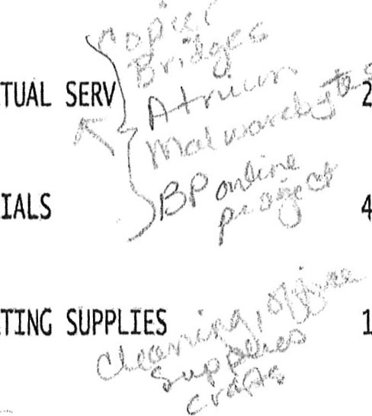

OPERATING

OTHER CONTRACTUAL SEW i,819.54 3,199.68 3,600.00 3,262.41

001-410-6502

LIBRARY MATERIALS 4,328.45  4,000.00 

10-6507

 1,951.05 3,646.34 4,000.00 410.92

001-410-6508

|  |  |  |  |  |  |
| --- | --- | --- | --- | --- | --- |
| POSTAGE  001-410-6599 | 93.95 | 65.74 | 120.00 | 19.83 |  |
| LIBRARY FUNDRAISER | 841,71 | 492.70 | 500,00 | .00 |  |

001-410-6770

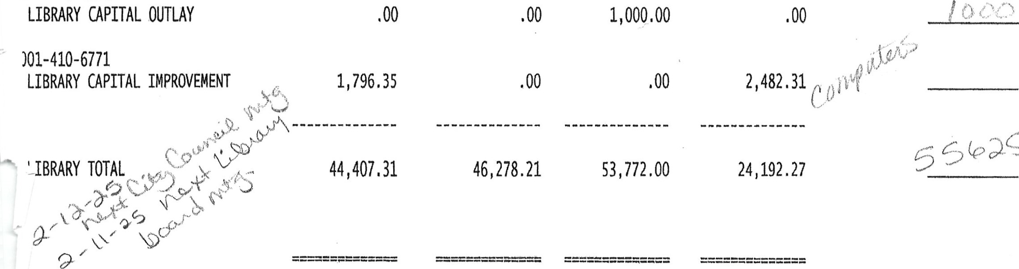

GENERAL TOTAL 44,407.31 46,278.21 53,772.00 24,192.27 

Deeper shelving for games & puzzles to be put on/displayed on

.WKSHRP 07/01/21 OPER: AC CITY OF SIOUX RAPIDS Statement Writer. 00 Report Format: EXPENSES